Operating the Air Compressor
- Location of Air Compressor
- Pre Start check
- Starting the Air compressor
- Shutting down the Air Compressor

1.Location of Air Compressor
The Air Compressor is located in the Air Compressor shed
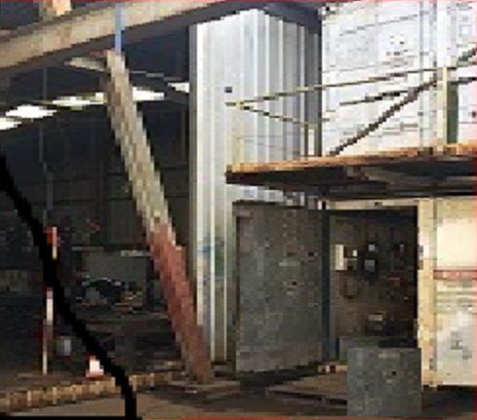

2. Pre Start check
Before starting the Air Compressor the water that has accumulated in the bottom of the Air Tank from previous usages can be drained. The Air Tank is located immediately behind the air compressor. There is a tap located at the centre of the bottom of the tank. The tap is opened and the water drains into a cup.

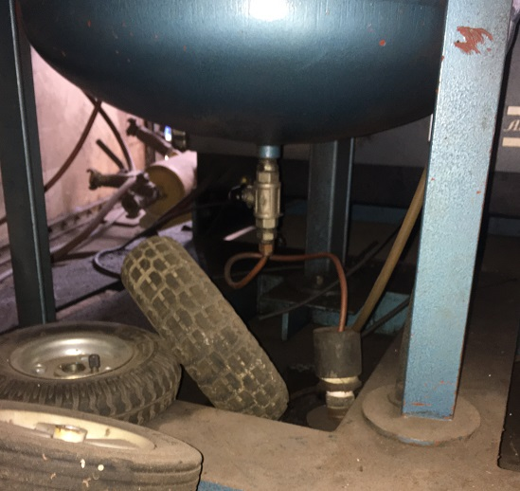

3. Starting the Air Compressor
[1]
The electrical switch board is located at about head height on the left hand side near the main entrance door. All three circuit breakers [coloured black, grey and orange] should be switched ON. In the ‘top’ position.  Wait 15 Seconds | 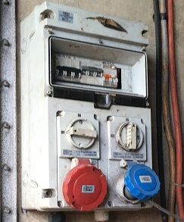
[2]
There are three switches with ‘hand written numbers ‘1, 2 and 3
Switch Number one is a green coloured switch. Switch it on and there will be a sound of a motor running. [This is the dryer unit which must be switched on before the compressor itself]  Wait 15 seconds. | 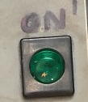
[3]
Switch Number two is a green coloured button which is pushed in to operate. The compressor itself will now start  Wait 15 seconds. | 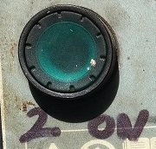
[4]
Switch Number three is a toggle switch. Push across to the left, next to the hand written “3 ON” | 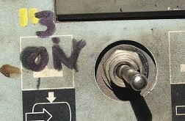
[5]
Then go and check that all the valves between the Air Compressor shed and the device requiring the air are turned ON
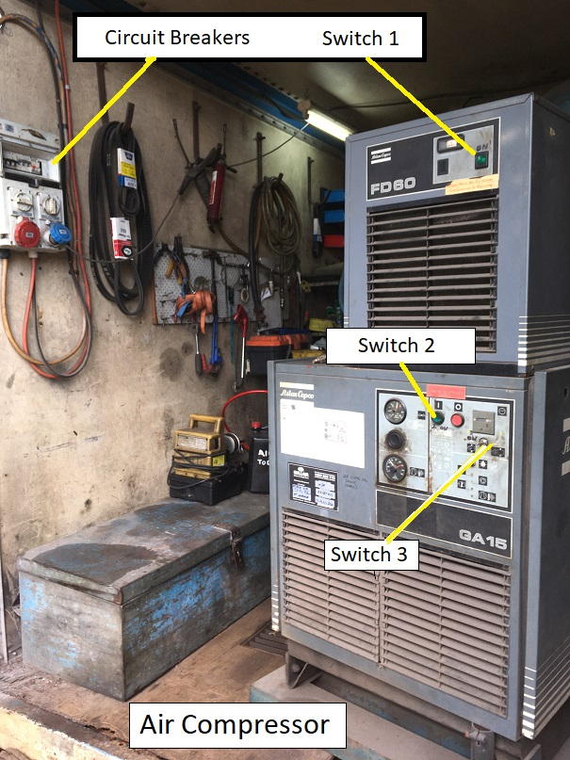
4.Shutting Down the Air Compressor
Perform all the above “Starting the Air Compressor’” instructions in the reverse order

