TABLE OF CONTENTS
- How does an anode work on boats cooling systems 2
- Location of anodes 2
- Checking Diesel Engine Anodes 3
- Removing broken off corroded anode from plug 4
- Cutting Copper Washers 5

How does an anode work on boats cooling systems
Anodes in boat cooling systems work by using the principle of galvanic corrosion to protect vital components from corrosion. When two dissimilar metals are in contact with an electrolyte, such as seawater, the less noble metal will corrode faster than the more noble metal, which remains protected. This process is known as galvanic corrosion. Anodes are made from metals that are less noble than the components they protect, such as zinc, aluminum, or magnesium. When the boat is in water, the anode corrodes first, sparing the other parts. Proper placement of anodes is crucial for their effectiveness, and they should make direct contact with the metal they’re protecting.

An engine has 4 anodes,  - 2 on the raw water pump (1 at intake, 1 at output)  - 2 on the header tank (1 either side)  - Anodes are Zinc (Zinc is for saltwater use only) | 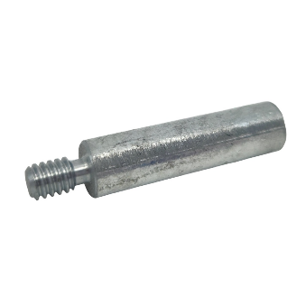
The anode is screwed into a threaded plug (with a copper washer between the two) which is then screwed into the engine block. | 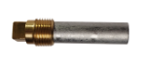

Location of anodes
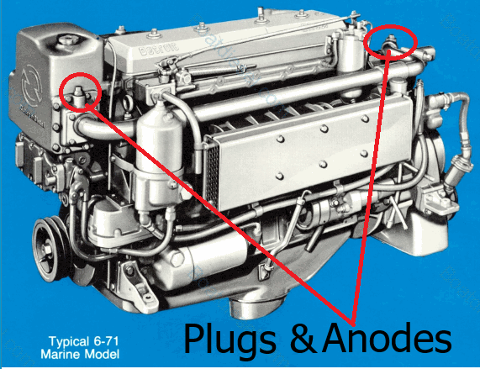

Checking Diesel Engine Anodes
Extract from Detroit Diesel manual
- Check heat exchanger electrodes (Zinc anodes) every 500 hours and clean every 1000 hours
Anodes must be checked on a regular basis to ensure they are performing their function, about every 6 months.
Unscrew the plug and pull out the attached anode.
Examine the state of the anode, If the anode is severely corroded, then it has performed its function of being a sacrificial anode and will need to be replaced
If the anode has not been severely corroded and it has been installed for a long period of time, then it has not been a sacrificial anode. You must then determine what caused the anode to be disconnected from the plug and lose the electrical connection
If the anode is not attached to the plug and is visible in the anode chamber, then it has worked its way free from the plug due to engine vibration. Extract the anode from the chamber using a pair of long nose pliers. The anode will probably not be severely corroded and may be cleaned and reinstalled.
When the anode is screwed into the plug use a copper washer between the two. Do not use plumbers tape or Locktite goo on any of the threads as they do not conduct electricity and will render the anode useless.
Corroded Plug & Anode
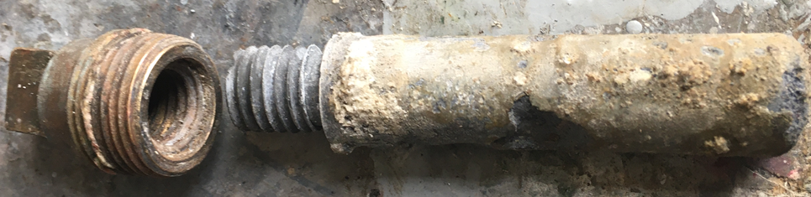

If the anode is to be replaced then the corroded anode must be unscrewed from the plug.
Place the square end of the plug in a vice and use a pair of pipe wrench Stilsons to slowly work the anode free.
The anode may snap off leaving some anode in the plug, this will need to be drilled out, see “Removing broken off anode from plug”
When screwing the new anode into the plug ensure the threads make metal to metal contact so as to complete the electrical circuit, If there no electrical connection between the plug and anode, then the anode will not work as intended and engine damage will result over time. The shoulder of the anode must be in contact with the base of the plug with a copper washer between them
Also note that Graphite was used occasionally on the anode thread to inhibit bonding to the plug. We will NOT apply Graphite as the plugs are brass and they should not cause much jamming with the anode, especially as they are looked at every six months.
Removing broken off anode from plug (Pieter Boon)
In some case the anode may not be badly corroded and the broken off bit can be easily removed by drilling a hole in it and using an easy-out, as there has been no bonding between the anode and plug
In the event that corroded anode cannot be removed from the plug, the procedure to remove it is as follows:
Place the square end of the plug in a benchtop drill vice to drill out the corroded anode

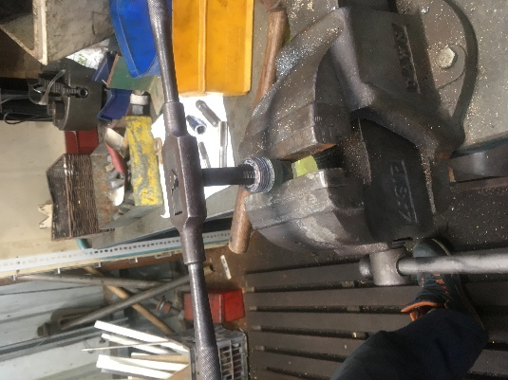

The anodes for the tugs Detroit Diesel 671 engines have a 5/8" Whitworth thread, this will require the 5/8" Whitworth (BSW 5/8) Tap and Die set
The Tap and Die set will have the sizes clearly marked on them. There are generally three taps in a set - a starting tap, a middle tap and a bottoming tap.
This video helps understand taps and die:
https://youtu.be/KVnN4jiB7Gk?si=H3YVQRg2rjLPJw1x
1. Using the benchtop drill press and vice, drill out the material starting with a small diameter drill bit and drill a hole through the centre of the corroded anode in the plug. When setting up the press and vice the drill bit must be centred and its depth stopped, so it only reaches as far as is needed in the plug and does not go through it.
2. Using progressively larger bits until you can easily use a 13mm drill bit through the centre of the anode and effectively remove most of the corroded anode.
3. Take the anode plug from the benchtop drill vice and place it in a vice to use the tap set.
4. Using the 5/8" Whitworth Tap set, start with the tapered starting tap and gently work the tap into the anode base ensuring that it is going in straight and not stripping the thread in the anode base.
5. Finally use the bottoming tap to complete the removal of the corroded anode. This should go in smoothly and if all the previous steps were done correctly, will easily cut out the rest of the anode.

After all the corroded anode has been removed clean up the plug and polish the bottom rim of the plug to ensure there is a good electrical connection with the new anode
Screw a new anode into the plug, placing a copper washer between the two, ensure that the shoulder of the anode touches the base of the plug.
Cutting Copper Washers (Barry Keppit)

Cut shims from 1/2" copper water pipe.  They are about 1-2mm slices. | 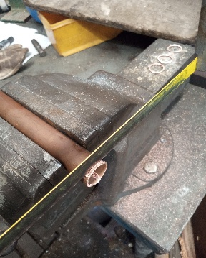
Ideally, they are left with rough surfaces so that they form a better grip on the anode when it is screwed into place.  As the anode is tightened into the plug the copper shim is squashed forming a good conduit between the brass plug and the anode.  NB The zinc material is brittle and shouldn't be over tightened | 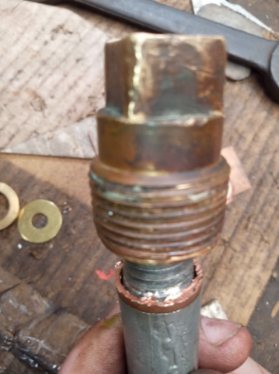

Extract from BoatUS
How Do Sacrificial Anodes Work? | BoatUS

For a zinc anode to provide any protection, it must be in electrical contact with the metal being protected. The conductivity of the water is not adequate. We need low-resistance, metal-to-metal contact — either by mounting the zinc directly to the metal being protected or by connecting the two with a wire. A hanging anode can provide protection if it is connected by a wire to the metal being protected.
Where the zinc is mounted directly to the protected metal — bolted to the side of a metal rudder, for example — it is essential to make sure the surface under the zinc is bare and bright before the anode is installed. This is to ensure good electrical contact.

No paint
Sacrificial anodes cannot perform their function unless they are exposed. Putting paint on an anode smothers it, rendering it useless. Never coat anodes with bottom paint, or anything else.

Zinc pencils
Heat exchangers, because they are typically a copper alloy, are at risk of galvanic corrosion. To combat this, many heat exchangers are fitted with a zinc "pencil" anode. You will find it (or not) under a brass plug in the exchanger. The pencil is unscrewed from the plug for replacement. Some engines have a similar zinc pencil inside the cooling-water jacket to protect dissimilar metals in the engine. Determine if your engine and heat exchanger are fitted with internal anodes, and if so, check them at least annually. If they are half depleted. . . well, you know.

